**CURRICULUM VITAE**

 **Career Objective**

**RAHUL PARSHURAM HALLI**

**EmailId:[rahulhalli2004@gmail.com](mailto:rahulhalli2004@gmail.com)**

**Contact No:** +91-7066973865

**Present Address:**

**MARKABBINHALLI DEVARHIPPERGI VIJAYAPUR**

**Personal Profile:**

**Name*: Rahul Parshuram Halli***

Father’s Name **:** Parshuram

Date of Birth **: 01** /06/ 2005 Gender **:** Male Nationality **:** Indian

Marital Status **:** UnMarried Languages **:** Kannada, Hindi, English & Marathi

To work in a dynamic environment which can fuel my professional growth and give me challenging tasks where I can enhance my skill & potential to my best & exploit them to create new avenues in the interest of the company.

 **Educational Qualification**

**Diploma in Computer Science and Engineering -:**

Percentage :

* 10th at Nursinh High school, pune Maharashtra SSLC board-75.20%

Year of passing : march2020

* Diploma in Computer science (3rd year) at BLDEA’s SSM Polytechnic
* 1 st Year-93.20%
* 2 nd Year-92.10%

Year of passing : march 2022



**Professional Strength**

* 1. Willing to be a learner and an implementer.
  2. Positive Thinking.
  3. Ability to work in team.
  4. Easily adaptable to the needs of work environment. PROFESSIONAL SKILL
* Artificial Intelligence and Machine Learning
* DBMS with basic
* Data structure with Python
* Basic in JAVA
* basic in HTML

**DECLARATION**

I consider myself familiar with the above mentioned aspects. I am also confident of my ability to work in a team. I here by, declare that the information furnished above is true to the best of my knowledge.

**Date:13/1/2023**

**Place: Vijayapur (Rahul Halli)**

**PHOTO GALLERY**

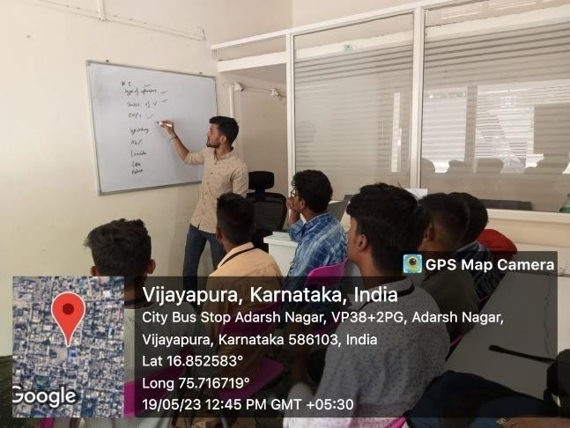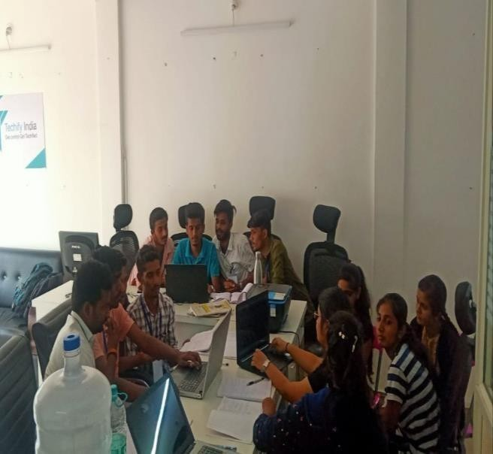

Fig-12.1 Fig-12.2

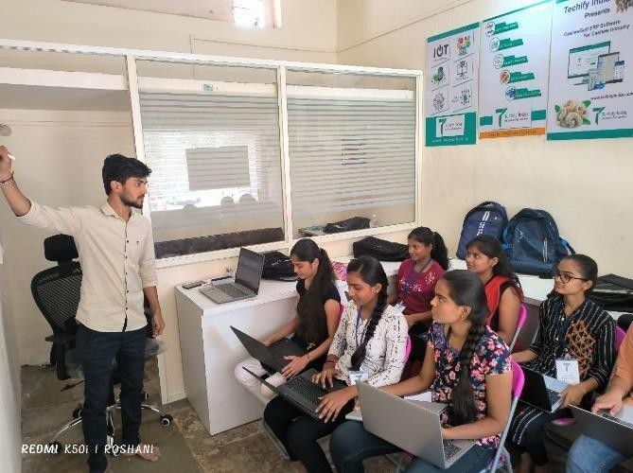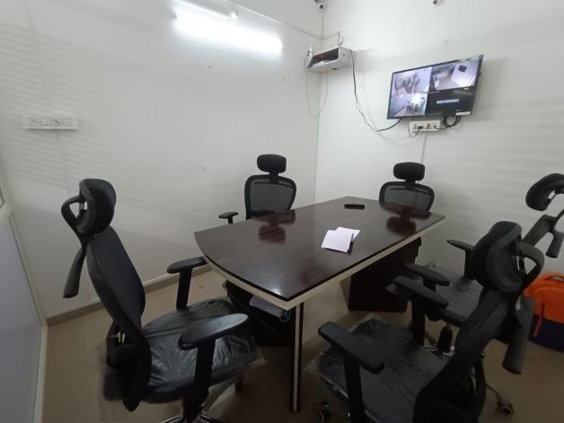

Fig-12.3 Fig-12.4

**APPENDICES**

Basic Python information – [https://medium.datadriveninvestor.com/python-programming-](https://medium.datadriveninvestor.com/python-programming-language-ac762a3b5977) [languageac762a3b5977](https://medium.datadriveninvestor.com/python-programming-language-ac762a3b5977)

Python OOPs Concepts – <https://www.javatpoint.com/python-oops-concepts>

Python important functions – [https://goutomroy.medium.com/python-lambda-map-filter-](https://goutomroy.medium.com/python-lambda-map-filter-reduce-261f29561fcc) [reduce261f29561fcc](https://goutomroy.medium.com/python-lambda-map-filter-reduce-261f29561fcc)

OpenCV tutorials - <https://docs.opencv.org/4.x/d0/de3/tutorial_py_intro.html>

OpenCV applications - <https://www.analyticssteps.com/blogs/open-cv-applications-functions>

Haarcascade xml files - <https://github.com/opencv/opencv/tree/master/data/haarcascades>

Smart city information - [https://www.wevolver.com/article/smart-city-internet-of-](https://www.wevolver.com/article/smart-city-internet-of-things-revolutionising-urban-living) [thingsrevolutionising-urban-living](https://www.wevolver.com/article/smart-city-internet-of-things-revolutionising-urban-living)

Vehicle detection and counting system - <https://predictly.co/vehicle-detection-counting-system/>

The images in the Chapter 1: Company’s profile were provided by the training supervisor.